**Texas Tech University**

**Department of Computer Science**

**Course:** Introduction to Artificial Intelligence **Group:** 1

**Student:** Felipe Chavarria Fernandez **Email:** fchavarriafernandez@gmail.com

**Date:** Friday, July 5, 2019

Table of Contents

Week 6 - Homework 6 1

Practice 1 1

Optional Problem 1b 4

TanH 4

ReLU 6

ELU 8

Practice 2 10

Practice 3 11

Without regularization: 11

With L2 regularization with 10 nodes 13

With L2 regularization with 25 nodes 15

With L2 regularization with 50 nodes 17

With L1 regularization with 50 nodes 19

Testing regularization_scale values: values: 1e-6, 4e-6, 1e-5, 4e-5, 1e-4, 4e-4 21

Optional Problem 3b 23

Without regularization: 24

With L2 regularization with 10 nodes 25

# Week 6 - Homework 6

## Practice 1

We start creating the lists to store the metrics for accuracy and cost for train and test data like so:

# Initialize lists

cost_against_training_data = []

cost_against_test_data = []

accuracy_against_training_data = []

accuracy_against_test_data = []

then in each evaluation step inside the while loops we store each of the metrics we compute:

# Save the metrics to the history

cost_against_training_data.append(trn_cost_avg)

cost_against_test_data.append(test_cost)

accuracy_against_training_data.append(train_accuracy)

accuracy_against_test_data.append(test_accuracy)

then we print the final results:

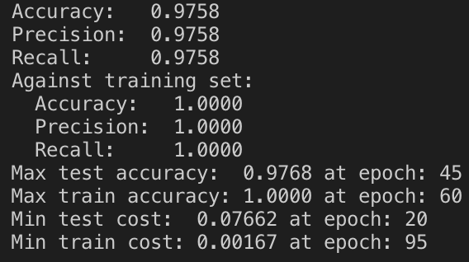

And plot Cost vs. epoch (both training and test) and Accuracy vs. epoch (both training and test):





## Optional Problem 1b

### TanH

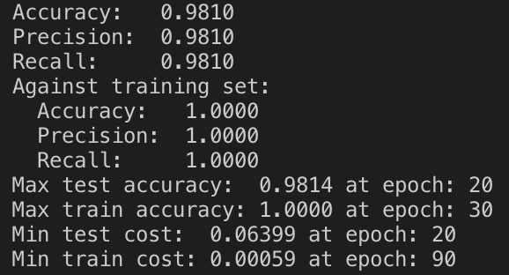

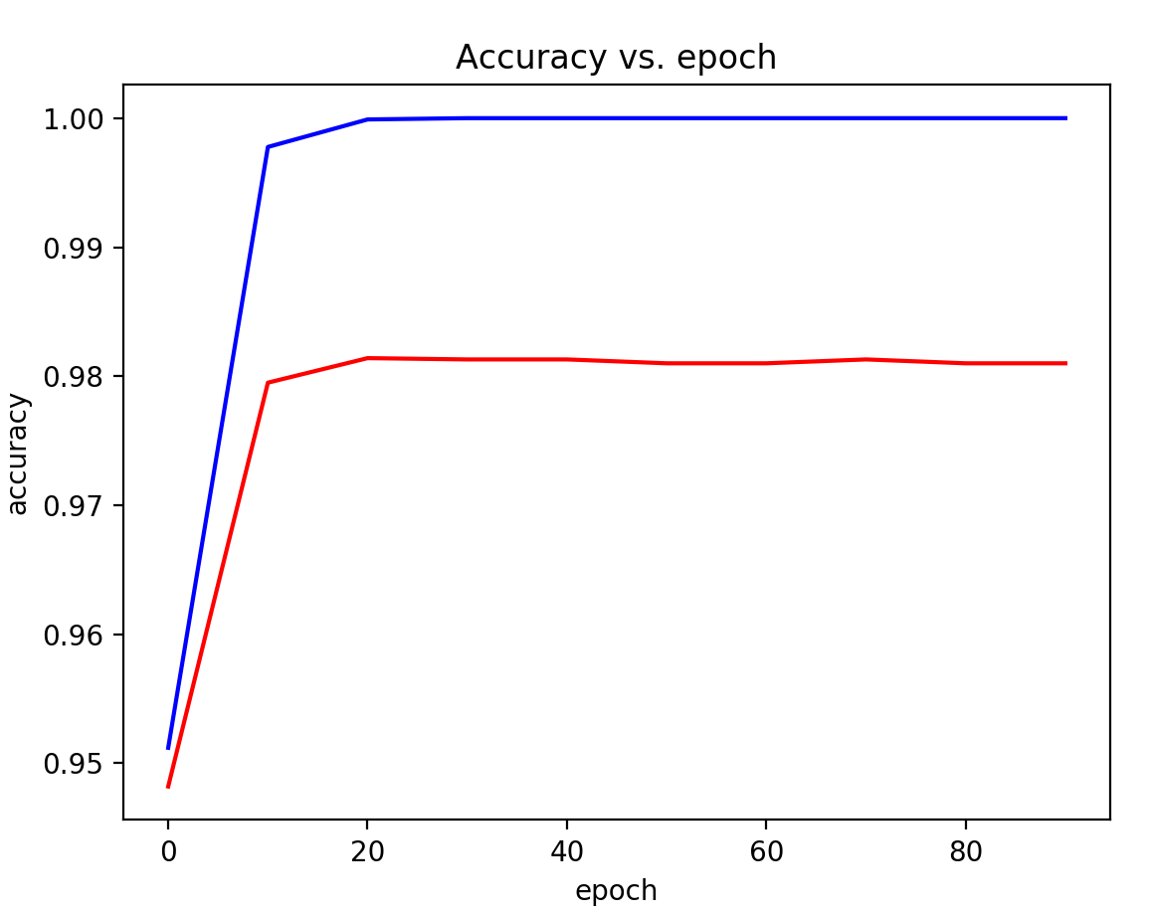

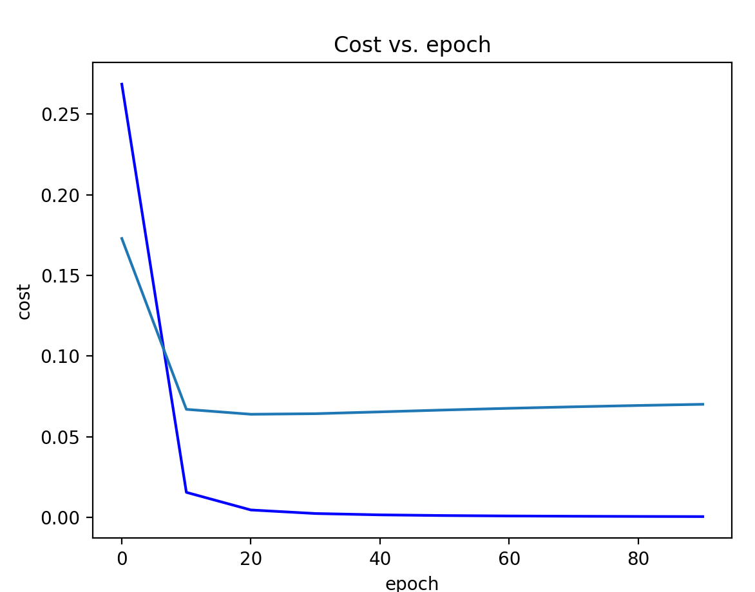

### ReLU

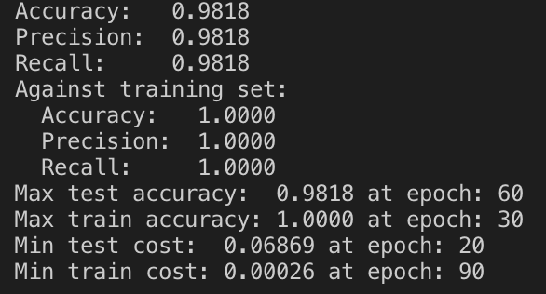

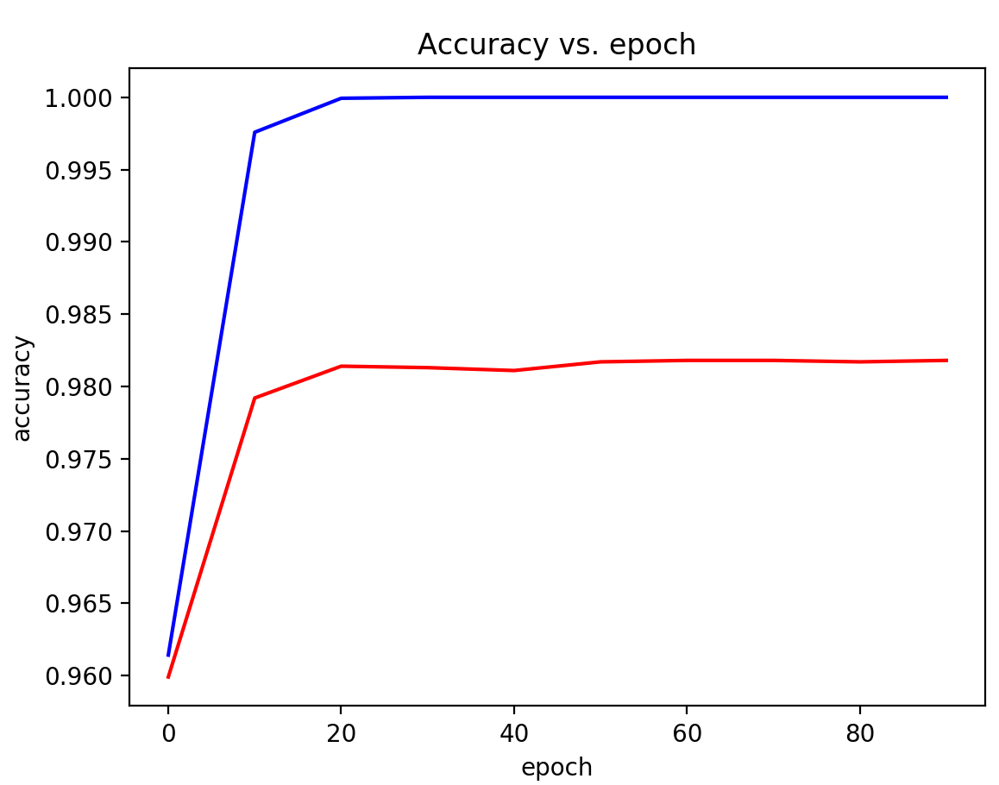

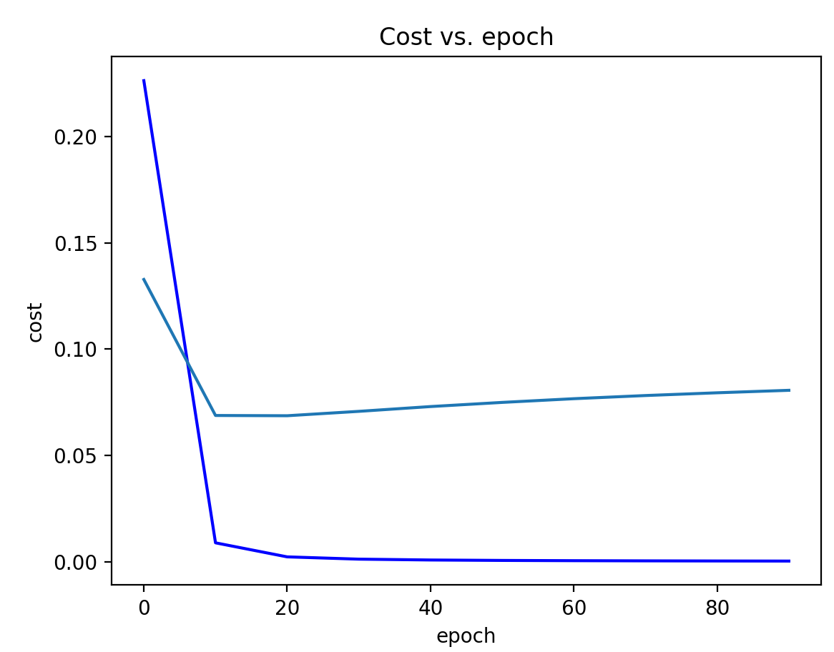

### ELU

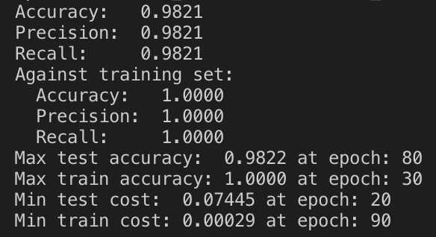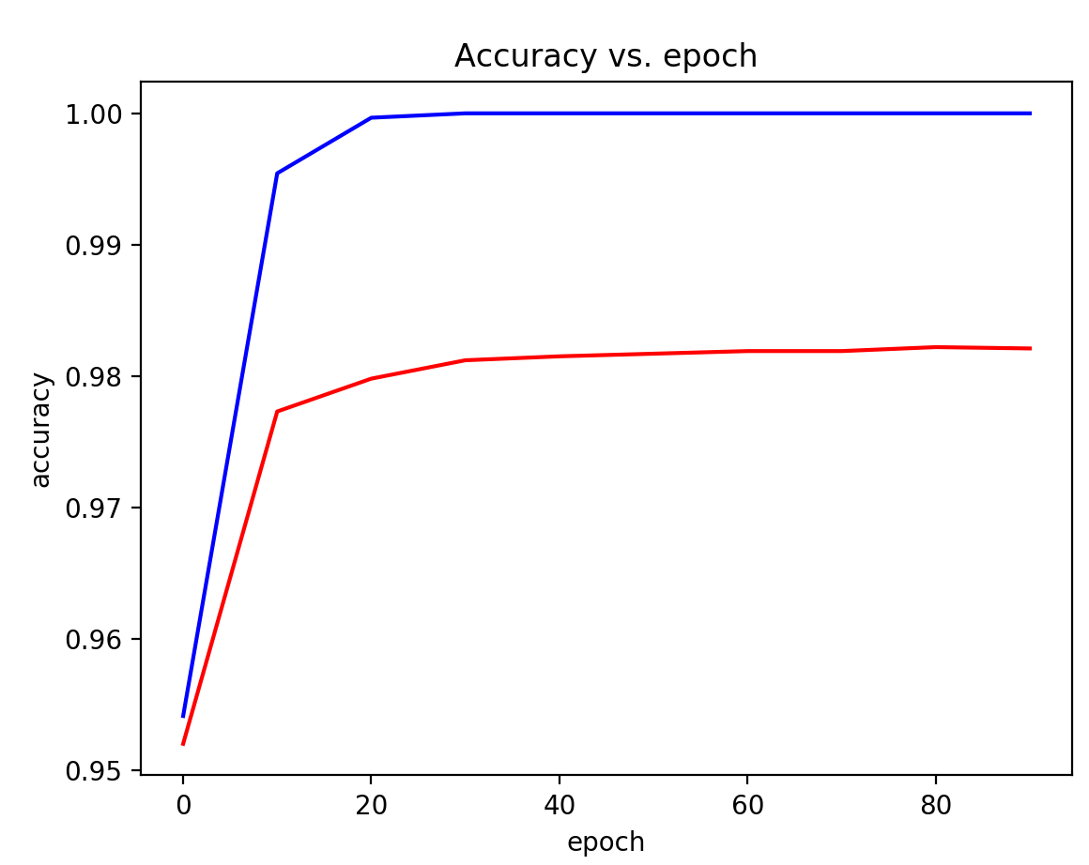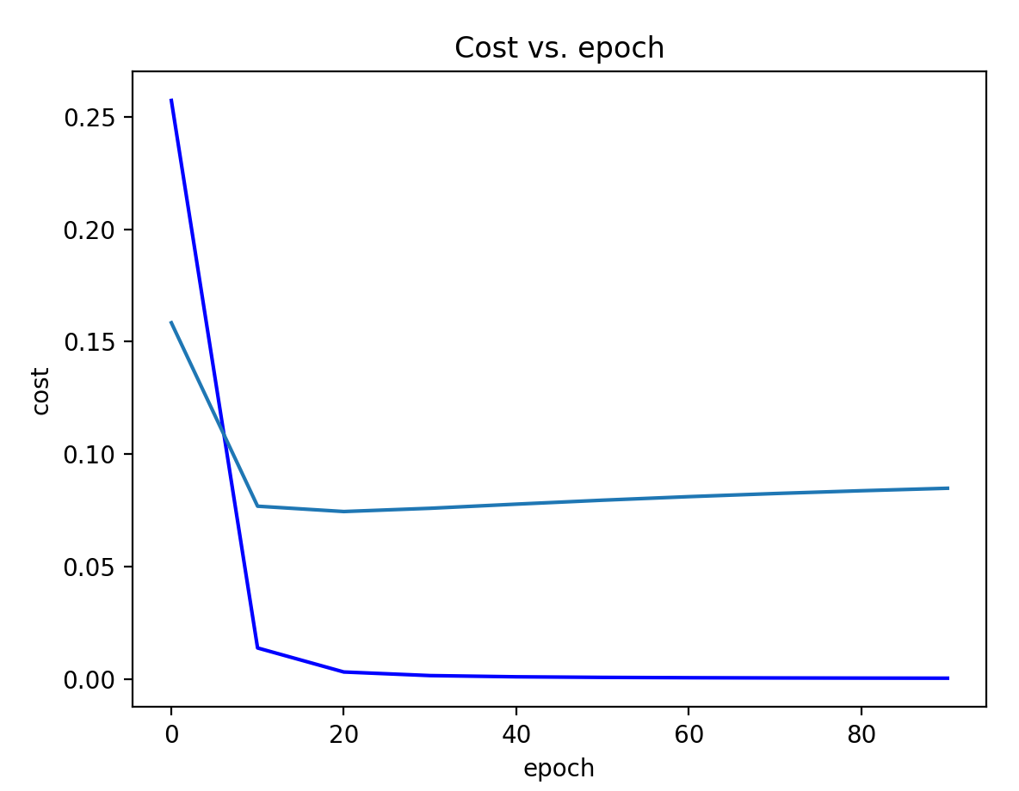

ELU ended up giving the best result with a max accuracy of 98.22 followed up closely by ReLU with a max accuracy of 98.18 and TanH also close but last with 98.14, But it was the other way around for the fastest activation function with TanH achieving the max accuracy at epoch 20, ReLU at epoch 60 and ELU at epoch 80.

## Practice 2

|  |  |  |
| --- | --- | --- |
| Activation Function /  # nodes | ELU | RELU |
| 5 | Max test ROC AUC: 0.7170 at epoch: 960  Max train ROC AUC: 0.7174 at epoch: 990  Min test cost: 0.47609 at epoch: 980  Min train cost: 0.47796 at epoch: 990 | Max test ROC AUC: 0.7001 at epoch: 40  Max train ROC AUC: 0.7067 at epoch: 970  Min test cost: 0.48500 at epoch: 50  Min train cost: 0.48321 at epoch: 990 |
| 10 | Max test ROC AUC: 0.7175 at epoch: 990  Max train ROC AUC: 0.7291 at epoch: 990  Min test cost: 0.47824 at epoch: 430  Min train cost: 0.47221 at epoch: 990 | Max test ROC AUC: 0.7142 at epoch: 860  Max train ROC AUC: 0.7248 at epoch: 990  Min test cost: 0.47872 at epoch: 660  Min train cost: 0.47536 at epoch: 990 |
| 15 | Max test ROC AUC: 0.7189 at epoch: 980  Max train ROC AUC: 0.7352 at epoch: 990  Min test cost: 0.47846 at epoch: 260  Min train cost: 0.46873 at epoch: 990 | Max test ROC AUC: 0.7123 at epoch: 270  Max train ROC AUC: 0.7310 at epoch: 980  Min test cost: 0.48227 at epoch: 100  Min train cost: 0.47158 at epoch: 990 |
| 20 | Max test ROC AUC: 0.7024 at epoch: 820  Max train ROC AUC: 0.7351 at epoch: 990  Min test cost: 0.48508 at epoch: 100  Min train cost: 0.46918 at epoch: 990 | Max test ROC AUC: 0.7183 at epoch: 350  Max train ROC AUC: 0.7389 at epoch: 990  Min test cost: 0.47872 at epoch: 350  Min train cost: 0.46713 at epoch: 980 |
| 30 | Max test ROC AUC: 0.7082 at epoch: 130  Max train ROC AUC: 0.7460 at epoch: 990  Min test cost: 0.48369 at epoch: 110  Min train cost: 0.46230 at epoch: 990 | Max test ROC AUC: 0.7147 at epoch: 380  Max train ROC AUC: 0.7516 at epoch: 990  Min test cost: 0.48272 at epoch: 100  Min train cost: 0.46016 at epoch: 990 |

As seen on the table above, there wasn’t much difference on the results using elu and relu.

The time it takes to converge for both elu and relu it’s almost the same for the min train and test and for elu the min test time to converge improve if a larger quantity of nodes is used, for relu it jumps for every example of different quantity of nodes.

## Practice 3

Using the MNIST problem based on Mnist_NN_3.py

### Without regularization:

Epoch: 1000 trn_cost: 0.37775 test_cost: 0.40450 trn_acc: 0.90077 test_acc: 0.89130

Max test accuracy: 0.8937 at epoch: 980

Max train accuracy: 0.9008 at epoch: 990

Min test cost: 0.40402 at epoch: 850

Min train cost: 0.37520 at epoch: 840





### With L2 regularization with 10 nodes

Epoch: 1000 trn_cost: 0.05490 test_cost: 0.06181 trn_acc: 0.93188 test_acc: 0.92270

Max test accuracy: 0.9257 at epoch: 810

Max train accuracy: 0.9345 at epoch: 800

Min test cost: 0.06076 at epoch: 800

Min train cost: 0.05487 at epoch: 950





### With L2 regularization with 25 nodes

Epoch: 1000 trn_cost: 0.03755 test_cost: 0.04758 trn_acc: 0.95962 test_acc: 0.94910

Max test accuracy: 0.9534 at epoch: 310

Max train accuracy: 0.9653 at epoch: 310

Min test cost: 0.04509 at epoch: 310

Min train cost: 0.03742 at epoch: 880





### With L2 regularization with 50 nodes

Epoch: 1000 trn_cost: 0.02994 test_cost: 0.03795 trn_acc: 0.97808 test_acc: 0.96580

Max test accuracy: 0.9677 at epoch: 930

Max train accuracy: 0.9787 at epoch: 810

Min test cost: 0.03727 at epoch: 670

Min train cost: 0.02994 at epoch: 990





### With L1 regularization with 50 nodes

Epoch: 1000 trn_cost: 0.05101 test_cost: 0.05781 trn_acc: 0.96310 test_acc: 0.95960

Max test accuracy: 0.9641 at epoch: 710

Max train accuracy: 0.9666 at epoch: 300

Min test cost: 0.05554 at epoch: 710

Min train cost: 0.05086 at epoch: 910





Given all of the previous results, L2 is slightly better than L1 regularization and adding more nodes will keep improving the results, at 50 nodes we are up to a 97% accuracy for the test data.

### Testing regularization_scale values: values: 1e-6, 4e-6, 1e-5, 4e-5, 1e-4, 4e-4

Batch size: 32

Num batches: 1875 Num epochs: 1000 Learning rate: 0.001

Num nodes in L1: 10 Activation function: ELU

Batch size: 32 Num batches: 1875 Num epochs: 1000 Learning rate: 0.001

Num nodes in L1: 10 Activation function: ELU

Regularization scale: 1e-06 Regularization type: L2

Epoch: 1000 trn_cost: 0.05711 test_cost: 0.08273 trn_acc: 0.89883 test_acc: 0.87730

Max test accuracy: 0.8947 at epoch: 10

Max train accuracy: 0.9063 at epoch: 700

Min test cost: 0.06957 at epoch: 10

Min train cost: 0.05703 at epoch: 900

Batch size: 32 Num batches: 1875 Num epochs: 1000 Learning rate: 0.001

Num nodes in L1: 10 Activation function: ELU

Regularization scale: 4e-06 Regularization type: L2

Epoch: 1000 trn_cost: 0.05245 test_cost: 0.07813 trn_acc: 0.91425 test_acc: 0.88600

Max test accuracy: 0.8923 at epoch: 10

Max train accuracy: 0.9181 at epoch: 580

Min test cost: 0.06995 at epoch: 10

Min train cost: 0.05245 at epoch: 990

Batch size: 32 Num batches: 1875 Num epochs: 1000 Learning rate: 0.001

Num nodes in L1: 10 Activation function: ELU

Regularization scale: 1e-05 Regularization type: L2

Epoch: 1000 trn_cost: 0.04779 test_cost: 0.06291 trn_acc: 0.93303 test_acc: 0.91610

Max test accuracy: 0.9167 at epoch: 980

Max train accuracy: 0.9337 at epoch: 920

Min test cost: 0.06276 at epoch: 980

Min train cost: 0.04772 at epoch: 980

Batch size: 32 Num batches: 1875 Num epochs: 1000 Learning rate: 0.001

Num nodes in L1: 10 Activation function: ELU

Regularization scale: 4e-05 Regularization type: L2

Epoch: 1000 trn_cost: 0.05696 test_cost: 0.06711 trn_acc: 0.92022 test_acc: 0.91110

Max test accuracy: 0.9122 at epoch: 810

Max train accuracy: 0.9243 at epoch: 250

Min test cost: 0.06659 at epoch: 140

Min train cost: 0.05691 at epoch: 760

Batch size: 32 Num batches: 1875 Num epochs: 1000 Learning rate: 0.001

Num nodes in L1: 10 Activation function: ELU

Regularization scale: 0.0001 Regularization type: L2

Epoch: 1000 trn_cost: 0.06794 test_cost: 0.07288 trn_acc: 0.91953 test_acc: 0.91760

Max test accuracy: 0.9178 at epoch: 400

Max train accuracy: 0.9196 at epoch: 870

Min test cost: 0.07284 at epoch: 840

Min train cost: 0.06788 at epoch: 120

Batch size: 32 Num batches: 1875 Num epochs: 1000 Learning rate: 0.001

Num nodes in L1: 10 Activation function: ELU

Regularization scale: 0.0004 Regularization type: L2

Epoch: 1000 trn_cost: 0.10012 test_cost: 0.10489 trn_acc: 0.89900 test_acc: 0.89600

Max test accuracy: 0.8971 at epoch: 60

Max train accuracy: 0.8997 at epoch: 80

Min test cost: 0.10464 at epoch: 80

Min train cost: 0.10011 at epoch: 290

From the previous the best result achieved was with the regularization_scale values at 0.0001

## Optional Problem 3b

### Without regularization:

Epoch: 1000 trn_cost: 0.37775 test_cost: 0.40450 trn_acc: 0.90077 test_acc: 0.89130

Max test accuracy: 0.8937 at epoch: 980

Max train accuracy: 0.9008 at epoch: 990

Min test cost: 0.40402 at epoch: 850

Min train cost: 0.37520 at epoch: 840





### With L2 regularization with 10 nodes

Epoch: 1000 trn_cost: 0.05490 test_cost: 0.06181 trn_acc: 0.93188 test_acc: 0.92270

Max test accuracy: 0.9257 at epoch: 810

Max train accuracy: 0.9345 at epoch: 800

Min test cost: 0.06076 at epoch: 800

Min train cost: 0.05487 at epoch: 950





As shown by the examples above, regularization improves the accuracy of the model. From 89% to 92% so in this case adding regularization is a good thing.

As shown in the Practice 3 results adding more nodes will improve the results of the model, it will come to a point where it takes a lot of time to get the results for a tiny fraction of improvement so, yes adding more nodes will improve the accuracy but it will be at a cost of long time to get the results.

The best results achieved were the following:

Epoch: 1000 trn_cost: 0.02994 test_cost: 0.03795 trn_acc: 0.97808 test_acc: 0.96580

Max test accuracy: 0.9677 at epoch: 930

Max train accuracy: 0.9787 at epoch: 810

Min test cost: 0.03727 at epoch: 670

Min train cost: 0.02994 at epoch: 990